Curriculum Helper Project

# Operation User Manual

03/29/2025

Table of Contents

1. Introduction 2

2. Installation 3

2.1 Installing Graphviz 3

2.2 Installing pdfplumber 4

3. System Overview 5

3.1 Main Menu 5

3.2 Transcript Parser 5

3.3 Progress Tracking 6

3.4 Planning Tools 7

3.4.1 Adding a course to your schedule 8

3.4.2 Removing a course from your schedule 10

3.4.3 Checking your schedule 10

3.5 Pre-Advising Checklist 11

3.6 Help Resources 12

4. Input/Output Formats 14

4.1 Input Formats 14

4.2 Output Formats 14

5. Troubleshooting and Known Issues 15

## Introduction

## Installation

### Installing Graphviz

Graphviz installation files can be found here: <https://graphviz.org/download/>

Click the “graphviz-12.2.0 64-bit EXE installer” to start the download. Run the .exe, click next, and agree to the license agreement. In install options, select “Add Graphviz to the system PATH for all users” and click next.

Figure : Adding Graphviz to the system PATH.

Make sure the Destination Folder is placed within the Program Files folder, click next, and click install.

Figure : Choosing the install location

Check your system files to confirm that Graphviz was installed into the proper file directory.

### Installing pdfplumber

Open the command prompt and install pdfplumber using pip:

|  |
| --- |
| pip install pdfplumber |

## System Overview

### Main Menu

The system’s features can be accessed using the main menu. The last button selection is displayed at the bottom of the menu.

Figure : Curriculum Helper Main Menu

This main menu is available until it is closed and can be used to access several features at once. Pressing Close on the main menu closes all Curriculum Helper windows.

### Transcript Parser

The first step to using the curriculum helper is to upload your transcript into the Transcript Parser. Click on Transcript Parser to open the Transcript Parser menu.

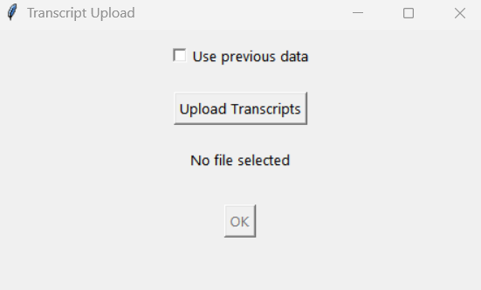

Figure : Transcript Parser

If you want to use already uploaded data, check the “Use previous data” checkbox and click OK. Doing so will display the message, “Using previous data from cache.”

If there is no cache or if you want to upload a different transcript, click on Upload Transcripts and find the PDF file of the transcript. The file should appear in the Transcript Parser menu. When the right file is selected, click OK to start the Transcript Parser.

Figure : Transcript Parser with selected file listed

### Progress Tracking

After uploading your transcript using the Transcript Parser, you can view the classes you have taken in the Progress Checker menu.

Figure : Progress Tracking menu

The name, course code, and grade for each class you have taken is displayed, as well as the total number of credits taken. You may have to scroll down to view every class depending on how many were read from your transcript.

### Planning Tools

The Schedule Selection menu can be used to add and remove classes from your schedule, and suggests courses based on the courses you have to take or have already taken as an Electrical Engineering major at USF.

Figure : Schedule Selection Main Menu

#### Adding a course to your schedule

Clicking “Add Course” opens the Add Classes menu, which asks confirmation on whether you are an upper-level student. Checking the box will allow the course planner to suggest all available courses, while leaving it blank will exclude it to lower-level courses.

Figure : Add Classes menu

Clicking “Confirm” brings you to a second menu that asks you to show all courses you haven’t taken yet or courses that the curriculum planner recommends to help you graduate.

Figure : Add Classes menu 2

After clicking “Show All” or “Show Recommended”, you will be presented with a list of course names and course codes. Click on which courses you would like to add and click save to add them to the schedule.

Figure : Add Courses menu 3

#### Removing a course from your schedule

To remove a course from your schedule, navigate to the Schedule Selector menu and click “Remove Class” to open the Remove Classes menu.

Figure : Remove Classes menu

To remove a class, click on the specified class and click “Save” to remove the course from the schedule.

#### Checking your schedule

To check your schedule, navigate to the Schedule Selector menu and click “Check Class” to open the Inspect Schedule menu.

Figure : Inspect Schedule menu

The name and code for each schedule is displayed along with the total number of credits in your course schedule.

### Pre-Advising Checklist

The Pre-Advising Checklist guides the user through the information requested by advisors prior to scheduling a meeting with academic advisors.

Figure : Pre-Advising Checklist (lower level)

Lower-level students generally schedule meetings with general engineering advisors and so need to enter information such as which college and major they are enrolled in, and which campus they are taking classes in. Upper-level students meet with a specific major advisor and only need to include their name, email, and UID.

Figure : Pre-Advising Checklist (upper level)

When you are finished filling in information and are ready to talk with an advisor, click on the blue link to be directed to where you can schedule an appointment. Note that data is not saved in this window, so all information should be copied or saved before you close the Pre-Advising Checklist window.

### Help Resources

Clicking on the help button displays the Help Resources window, which includes hyperlinks to Academic Support Services, Faculty Directory, and other resources.

Figure : Resource Links

## Input/Output Formats

### Input Formats

PDF is the file format of the transcript uploaded by the user.

### Output Formats

PNG is the file format of the flowchart output, if requested by the user.

## Troubleshooting and Known Issues